Nick Telerico

IMS 413

September 28, 2020

DESIGN CONCEPTING

When I read over the assignment for the week, I got very excited very quickly. It has been a while since I have done an activity like this, and the last time I remember an experience similar to this was when I was a member in Igoodea Creatives, a business organization. Yes, doing the Crazy 8s is recommended on paper, but I immediately went to my handy sticky notes that all always on my desk.

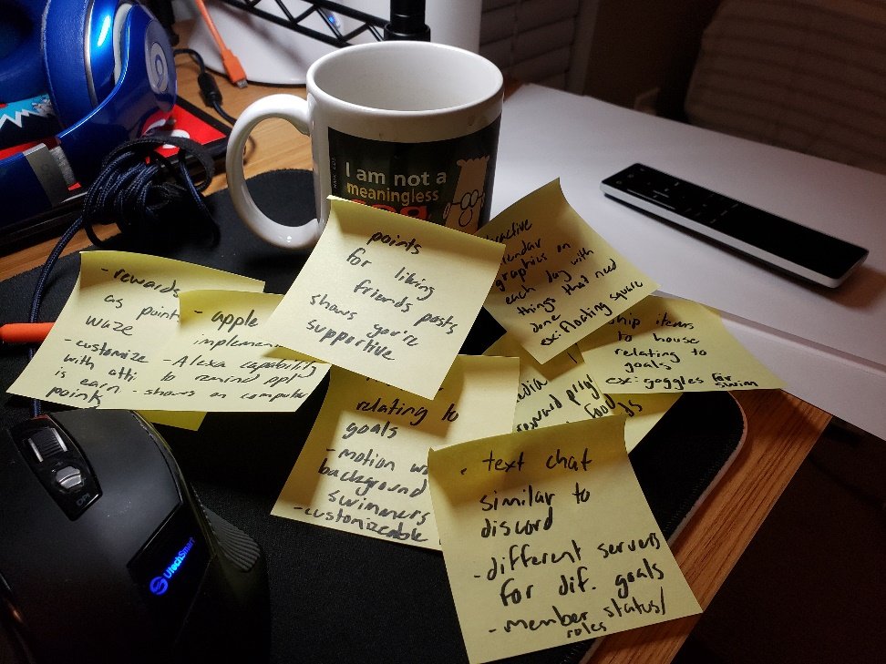**Crazy 8s**

Here is the carnage of ideation next to my favorite coffee mug with Dilbert on it. The first couple of stickies were awesome and effortless, but it soon became stressful because my ideas were running out. Obviously, I am a little rusty with my ideation, but seeing these sticky notes reminds me of the quality ideas in the past I created with simple brainstorming. I aimed to take on the challenge of eliminating boredom and monotony out of habit tracking. I had to look back at my findings from my interviews and then my user persona to remember everything I wrote after an insane week of exams.

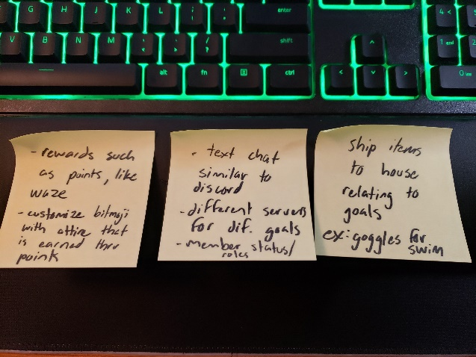**My Top 3:**

When I read these over after my brainstorming period, I literally said “yes” because they relate so much to the target I am aiming at. The first one relates to Snapchat’s Bitmoji characters and how user can create them in their own image. The twist with this is attire is unlocked based on points earned… or points can be used to buy attire (not sure). The second one is probably my number one due to the magic of Discord and the interaction it brings to its users. Discord is the most popular social media platform for gaming, and the servers could easily be converted over to my app. The last sticky deals with the excitement that is brought with people’s subscriptions. There are services that have monthly shipments of certain products, and a habit tracker with monthly shipments sounds awesome.

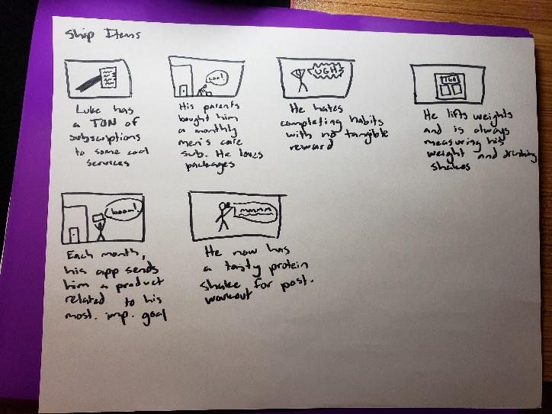**Story Boards:**

I really enjoyed story boarding. This actually made me think about the idea with a subscription even more. When I think about the story behind it, I think it could really work and be effective. Overall, this definitely helped me the most with ideating because this encompassed what my target market will go through to end up using my app. It also highlights the pain points I discovered during my interviews. To be honest, this part was so much fun, and I genuinely learned a ton from storyboarding.

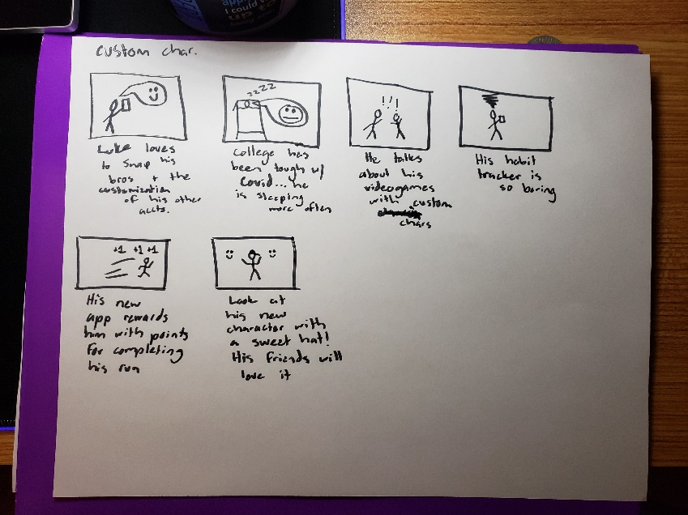

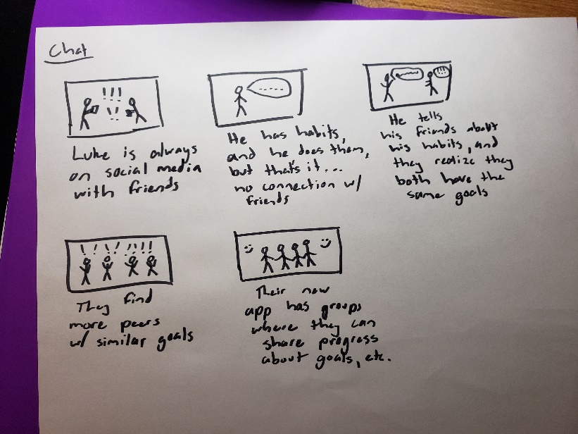

**Sketching:**

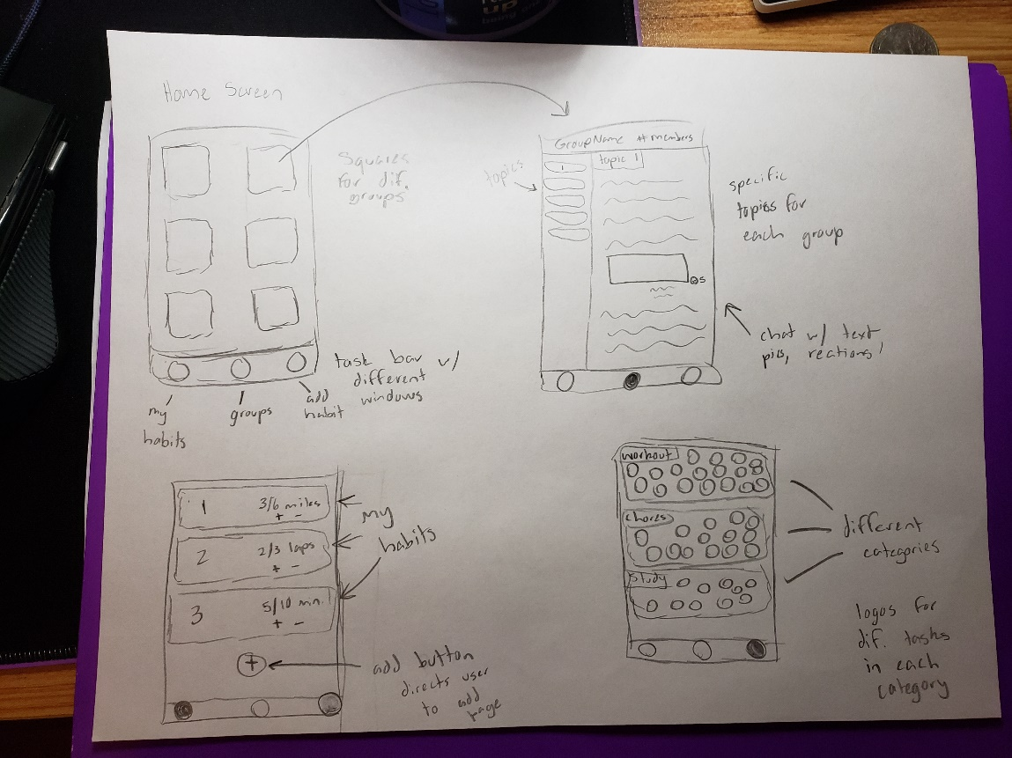

I did some mockups for what the user interface could look like for a chat-based habit-tracker app. Obviously, pencil is boring, and eventually these interfaces will be full of vibrant colors. The screens are button-based, making each page easy to navigate. The chat page is an exception, and it will have many features similar to regular group chats. There will be a task bar at the bottom for easy switching between pages.

What really stood out to me from my persona was the quote about how the person wants to complete habits without them feeling like tasks. The is derived from the boredom and monotony some of these apps have. Also, the fact that the user is driven by social media influenced my approach to the assignment. It is interesting to see how social media has exploded and now practically everyone with a phone is on it. The world is more connected than ever, and I tried to take advantage of that.